Livingston Bay Board Meeting Minutes

Date: July 29, 2017 3:00PM
Place: Camano Island Library
President: John Gablehouse
Vice President: Don Iverson
Secretary: Eric Moran
Treasurer: Mike Yonker
Member at Larger: Francis Straus

CALL TO ORDER
The meeting was called to order at 3:00 PM with at least 10 properties represented including three new community members, thank you all for your participation.
Finance update and status
***Mike Yonker gave financial report. Community is working on saving money for water system upgrades, community chose not to update system with a long term loan last year in favor of working with funds in hand and taking a staggered approach in phases. New items on P&L, shows additional income from excessive water usage and transfer fees from home sales for property title changes. We are finically stable, cut the budget, used community members to help perform tasks, and system fixes have been stable. The Board cleaned pump house, roof, fixed generator, well housing, generator gate access, etc. Available balance is about $87k, with the possibility of reaching $100k by end of year.
King Water “Consumption Report” Second Quarter
*** 12 people over limit with only 3 users that are WAY over the limit. This year to date, the total gallons pumped from our well was 915k gallons, which is 300k gallons less than 2016. The highest individual consumer was 58,000 gallons for one quarter. John explained the escalating cost of water consumption and how it affects every part of our costs, from electricity to green sand, to general wear and tear.
Action Item: John suggests that we look into an adjustment to Camano Marine water contract.

Storage tank and water main test results June 2017 test
*** King Water and the board performed a leak test on the main storage tank and the upper section of main piping from the Hydrant down to Lot 59. All homeowner meters were closed to isolate just the main pipe. The test results were that we only lost 9 gallons of water over 2 hours on the main piping, and we lost 1/8” in level in the main 65k gallon concrete tank. For the next test, we will shut down div 1 and test that segment the same way. We are well below water loss standards for Washington. We found a possible patch repair that may stop leaks without having to replace tank. We will try that when the tank is cleaned next. The next date is unknown for tank cleaning, waiting for king water. Tank only dropped an 1/8th of an inch after 4 hours of static time.
Pump house maintenance
*** John suggest community involvement to send out a flier, Eric will make a task list. John will make a list of tasks and set an agenda. August 26th is the date for work party
a. Downspout replacement
b. Fence cleaning & painting
c. Insulation replacement
d. Heater replacement Eric
e. Security light repair/replace Eric
f. Pressure tank Installation Eric
g. Generator update/maintenance Eric/John
h. Door lock replacement Eric/John
Property area around Storage Tank
****LBCA does not own very much property around water tank and well head. John describes ownership with a map. John explains wanting to establish a foot path around Lot 2-1 following our 15 foot easement that already exists for water and drainage from the water system to the Roberge pond. John suggests that the community explores purchasing the property from lot 2-1. Don explains what is needed to get a new well drilled in new community area, 100 foot radius around well, etc., just exploring for now.
Water Conservation Program
**** People are conserving now, doing good. We have already pumped 300,000 gallons less from our well this year as compared to last year. Great job team!!
LBCA Board Policy Book
***John Henderson was tasked with creating a community book that will be distributed to new community members. John did a great job! Interim policy regarding community property discrepancies started in 2015. John has also volunteered to go through the information that is paper and digitize it for the community. Any changes needed, get with John Henderson and discuss. Community information requests will incur a fee for printing charges after 5 documents. John H will make 5 Books, one for each Board officer to pass down.
Community Contact Information (updating)
*** John Henderson made a form to update all community member information, state law says you have to have property owner information on file. Should we make a community roster for volunteering, with a check box saying you can contact people that want to volunteer?

Transfer fees-
****$250 each time a property is sold. This helps in recovering costs and saving for capital improvements, separate from water system. Community members will get a book now as well. Other communities on the island charge $1,000 for title change fees.

Question about fairness of transfer fees being reasonable and “Do we refund to one owner requesting refund?” Board votes unanimously to NOT give refund and stay with $250 fee as is.

Community Property use (Trailers/camping/yard waste, machinery access)
*** Family was using community property with camper on it. What do we do? Should the board allow selected use of community property? Weddings, parking, etc. Could we use approval process that would be used for equipment use on water side, we are asking for $250 fee to retain for damage if incurred? Liability would be covered by A hold harmless agreement, and it would only affect next to lot 59.
Define passive use. Weddings, volleyball, etc. Feel is no camping etc. Keep policy as is, no rv and trailers, casual use is example of tents for kids etc. No use after 9PM?
Yard waste shall not be dumped on community property. A flier will be sent out concerning this. Mike, John and Bob Gibbs took out 2.3 tons of organic matter and garbage from one community property access path.
Information requests/ reproduction cost/fees
*** after 5 copies we charge

Community file storage
***WEB SITE, previous board members will not release the web site, John is working to get it fixed. Ericka will help John look and see what it will take. www.livingstonbay.org
Encroachment update and policy
***When previous board had survey done to div #1, board was driven by a requirement from Shoreline Management “SM”to develop a policy short of formal enforcement by SM, any work on community property cannot be permitted, permits are only valid when requested by the owner of the property, that is the board for community property. Individual property owners can only take out permits for their own property. The Board at that time had set a procedure that “when your property is transferred, you will remove encroachment before selling and revert property back to its natural state.” Or the community will charge owner to repair encroachment. We have had a fence issue, and now a bulkhead issue to review. All of this was required by Shoreline management.
The Secretary, Eric, disclosed that he received an email from Lot 1-8 requesting all board minutes from 2010. This is in work and the homeowner has also been directed to the community web site www.livingstonbay.org.
Trail development/plan update/Community property Signs
***John shows hand drawn map showing proposed trail plan for the community. SEE PICTURE Looking to put signs to lead people along the path. Committee proposal? Ericka proposes a committee for the community trails. Don discussed path and trail development ideas, possibly tie Juniper Bay with Livingston Bay via path along highway.
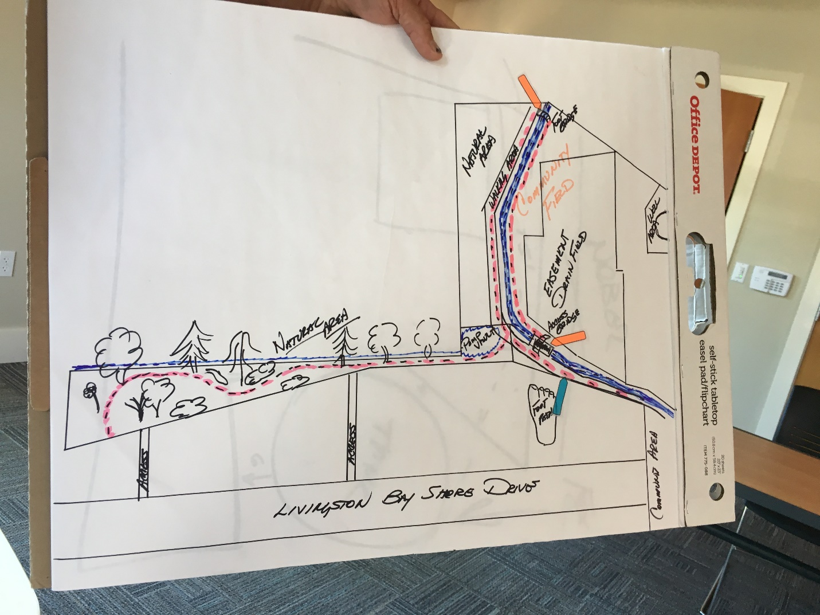
Beach cleanup/ picnic
***Samantha and Sheena will put out fliers and dates for clean-up and food.
Election Committee update Community website
***Ginny Berube reports that there are two candidates, and they will send out ballots by August 21st.

Legal opinion and recommendation regarding long and short term home rental policy
***Air BnB, John requested legal advice from Cole and Cole, you cannot distinguish between long and short-term rentals. The only way to allow Air BnB indemnified from liability. We are exploring ways to regulate or manage the short term rentals, to manage the issues. Possible small committee to make recommendation on process.

Drainage Ditch pump/vault
***Don, John, Mike and Eric going to fix pump vault.

Home Construction Completion Period
*** Put siding on house and finish landscaping per bylaws and CC&r’s.

Committees (Trail/Rental/Landscape)
*** John is going to send out notices for upcoming committees.
Old/New Business
When does water quality test come in? A: King will send out to individual homeowners via US Mail when completed.
Will everyone get all water results? A: We are trying to keep them private so people are not shamed by others consumption. John will get statistics for individuals when requested.
Meeting Adjourned at 5:00PM

Notes taken by Eric Moran, Secretary LBCA 206-510-3413

