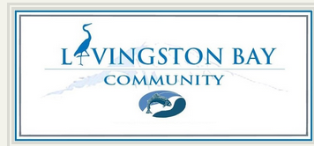

August 16, 2018

Dear Community,

The Livingston Bay Association Board has scheduled a regular Board Meeting on Sunday, August 26, 2018, from 4-6:30 pm at the Camano Island Library located at 848 N Sunrise Blvd, Camano Island.

The agenda will include:
- Treasurer report regarding budget
- Water system improvements
- Storage Tank cleaning/relining update
- Roberge drainage easement/Attorney review
- Deteriorated/damaged culvert repair/removal
- Easements
- Election process/update
- Division II property survey
- Use of Volunteers
- Community property signs
- Walking path update
- Culvert and drainage ditch evaluation on natural area
- Website updating
- Encroachment policy/encroachment complaints
- Pumphouse repairs/generator maintenance
- New business

Thanks,

LBCA Board

